Anechoic Configurable Hemispheric Environment for Spatialised Sound

The original Configurable Hemispheric Environment for Spatialised Sound (CHESS) was a 3D sound environment that allowed for playback of up to 16 channels of audio using loudspeakers attached to a hemispheric framework. It was created in 2001 as a collaborative project between the 3D audio team in Informatics, led by Ian Burnett, and staff in the sound, composition, music and production program from Creative Arts, led by Stephen Ingham.

CHESS has been the principal infrastructure used for research activities in spatial sound. A photo of the original CHESS system, which includes a 3D loudspeaker array, is shown in Figure 1. Technology resulting from this research was used in an international symposium on sonification, and for the production of a 16-channel electroacoustic composition created collaboratively between the Faculties of Informatics and Creative Arts.

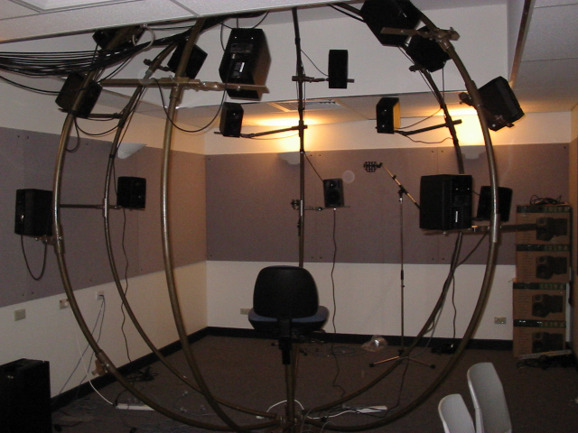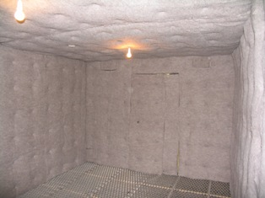
The Original CHESS facility Anechoic CHESS

The upgraded facility has created an anechoic environment for spatial sound. This will enable a wealth of new research activities previously not possible with the original CHESS facility. The new facility allows anechoic recording and playback (via the 16 channel hemisphere) and is used for research into spatial audio coding, microphone array design, microphone array speech enhancement and recording and numerous other projects.

